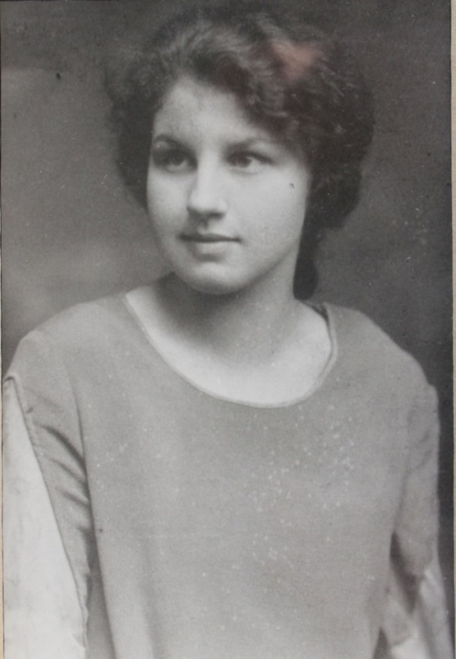

Dorothy Elizabeth Wolfe List Worthen – about 1925 (est.)

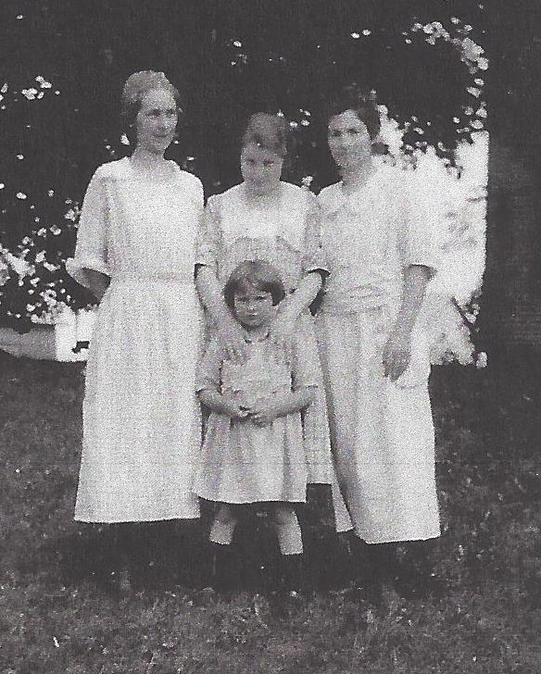

**Women: Anna Worthen, Dorothy E. Wolfe & Josephine S. Worthen Wolfe**

**Child: Josephine Ann Wolfe – 1925** (est.)